Pipeline, CI/CD pipeline and Software Delivery Pipeline

1-pipeline
# Source: Chatgpt (GPT-5-Standard) at [8/13/2025]
In software development (especially DevOps), a pipeline is an automated sequence of steps that code goes through — from the moment a developer commits changes until it’s tested, built, and deployed to production (or another environment).
Think of it like an assembly line in a factory, but for software:
- Each stage performs a specific task (build, test, deploy).
- The output of one stage becomes the input for the next.
- If something fails at any stage, the process stops to prevent bad code from moving forward.

Key Points About a Pipeline
# Source: Chatgpt (GPT-5-Standard) at [8/13/2025]
- Automated → Once triggered (e.g., when code is pushed), it runs without manual intervention.
- Repeatable → Same steps run every time, ensuring consistency.
- Configurable → You define the stages, tools, and order.
- Integrated with CI/CD → Pipelines make Continuous Integration and Continuous Delivery/Deployment possible.

Typical Pipeline Stages
# Source: Chatgpt (GPT-5-Standard) at [8/13/2025]
- Source – Detect code changes (commit, pull request).
- Build – Compile the code, package it, and prepare artifacts.
- Test – Run automated tests:
  - Unit tests
  - Integration tests
  - API/UI tests
- Deploy – Move code to staging or production environment.
- Post-Deployment Checks – Smoke tests, monitoring, rollback if needed.

Example – Simple CI/CD Pipeline
# Source: Chatgpt (GPT-5-Standard) at [8/13/2025]
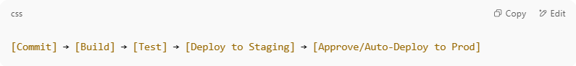
[Commit] → [Build] → [Test] → [Deploy to Staging] → [Approve/Auto-Deploy to Prod]

Why Pipelines Matter
# Source: Chatgpt (GPT-5-Standard) at [8/13/2025]
- Speed – Changes can go from idea to production quickly.
- Quality – Automated tests ensure only working code moves forward.
- Reliability – Fewer human errors compared to manual deployments.
- Feedback – Developers know within minutes if their change broke something.

2-CI/CD pipeline
# Source: Chatgpt (GPT-5-Standard) at [9/8/2025]
A CI/CD pipeline is a set of automated steps that help teams build, test, and deliver software faster and with fewer errors.
It combines two main ideas:

1. CI → Continuous Integration
# Source: Chatgpt (GPT-5-Standard) at [9/8/2025]
- Developers frequently merge (integrate) their code into a shared repository.
- Every change triggers an automatic build and automatic tests.
- Goal: detect problems early, keep the codebase always working.
Example steps:
- Developer pushes code.
- Code is compiled/built.
- Automated tests run (unit, integration, etc.).
- If something breaks → alert the team immediately.

Integration
# Source: Chatgpt (GPT-5-Standard) at [9/8/2025]
In software/DevOps context, Integration means:
Combining code changes from different developers, teams, or modules into a single shared build — then making sure it all works together.

🔹 Simple idea
- Developers work on separate pieces (branches, modules).
- Eventually, those pieces need to fit together.
- Integration is the process of putting them together, building, and verifying that nothing breaks when combined.

🔹 Types / contexts of integration
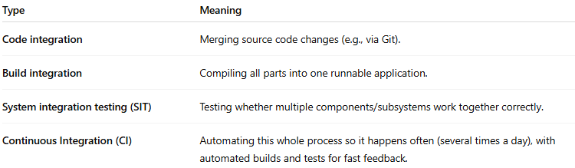
Type | Meaning
Code integration | Merging source code changes (e.g., via Git).
Build integration | Compiling all parts into one runnable application.
System integration testing (SIT) | Testing whether multiple components/subsystems work together correctly.
Continuous Integration (CI) | Automating this whole process so it happens often (several times a day), with automated builds and tests for fast feedback.

💡 In short:
Integration = putting the pieces together, early and often, to confirm that the whole system works as intended.
Would you like me to also explain how integration fits in the bigger picture (Integration → Delivery → Deployment → Release) in one flow?

automatic build
# Source: Chatgpt (GPT-5-Standard) at [9/8/2025]
An automatic build means: as soon as you change the code (for example, push to GitHub), a tool automatically takes care of turning that code into something usable — without you doing manual steps on your machine.

In other words
A “build” is the process of:
- Fetching the code and dependencies
- Compiling it (if needed)
- Running scripts that prepare it (minifying, packaging, etc.)
- Producing output (an executable, a web app bundle, a Docker image, etc.)
When it’s automatic:
- A CI/CD tool (like Jenkins, GitHub Actions, GitLab CI, Azure DevOps, etc.) does it for you.
- It triggers every time there’s a code change — no waiting, no manual clicking.
- It ensures everyone always works with a clean, fresh, consistent build.

💡 Quick example:
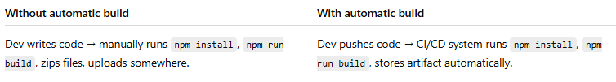
Without automatic build | With automatic build
Dev writes code → manually runs npm install, npm run build, zips files, uploads somewhere. | Dev pushes code → CI/CD system runs npm install, npm run build, stores artifact automatically.

automatic test
# Source: Chatgpt (GPT-5-Standard) at [9/8/2025]
An automatic test (or automated test) means: a program checks whether your software works as expected — by itself, without a person manually clicking or typing.

In simple terms
- Instead of a tester opening the app and trying every button,
- You write test scripts once (code that simulates what a user or system would do).
- A tool runs these scripts automatically (often right after the automatic build).
- If something fails, the system shows a red flag immediately.

Typical kinds of automated tests
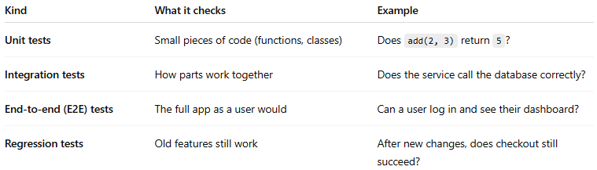
Kind | What it checks | Example
Unit tests | Small pieces of code (functions, classes) | Does add(2, 3) return 5?
Integration tests | How parts work together | Does the service call the database correctly?
End-to-end (E2E) tests | The full app as a user would | Can a user log in and see their dashboard?
Regression tests | Old features still work | After new changes, does checkout still succeed?

💡 Why it’s important
- Finds bugs early and fast
- Saves a lot of manual work
- Works the same every time (no human mistakes)
- Fits perfectly into a CI/CD pipeline → after automatic build, you run automatic tests to make sure the build is safe to deploy.

CI promotes
# Source: Chatgpt (GPT-5-Standard) at [9/8/2025]
In Continuous Integration (CI), the word “promote” usually means:
➡️ Moving a build, artifact, or code change from one stage to the next in the delivery pipeline.

🔹 Example in CI/CD
- Developer commits code → CI builds it.
- The build passes tests → it gets promoted to the next environment:
  - From dev → test
  - From test → staging
  - From staging → production
So promotion = saying “this build is good, let’s advance it forward.”

🔹 When people say “CI promotes …” they usually mean:
- CI promotes code quality → because it enforces frequent testing.
- CI promotes automation → less manual effort.
- CI promotes rapid feedback → developers know quickly if something broke.
- CI promotes reliable releases → builds are tested at each step before promotion to production.

💡 In short:
In CI, “promote” means either moving builds forward in the pipeline or encouraging better practices like quality, automation, and fast feedback.

CI promotes shift left
# Source: Chatgpt (GPT-5-Standard) at [9/8/2025]
When people say “CI promotes shift left”, they mean:
- CI (Continuous Integration) encourages testing and quality checks to happen earlier in the software development process — i.e., “to the left” on the typical left-to-right timeline (plan → code → build → test → release → operate).
- Instead of waiting until the QA or staging phase to discover problems, CI runs automated builds, tests, static analysis, security scans, etc., immediately after each code change is integrated.

🖼️ Simple way to see it
- Old way → code a lot → then test at the end → find problems late (costly to fix).
- Shift left → integrate and test small changes all the time → find and fix issues early (cheaper, faster).

💡 In other words:
CI promotes (encourages, supports) the shift-left approach by making early integration, automated testing, and fast feedback normal practice.

CI Frameworks
# Source: Chatgpt (GPT-5-Standard) at [9/10/2025]
🔄 CI Frameworks — Definition
CI stands for Continuous Integration. A CI framework is the combination of tools, scripts, pipelines, and practices that allow developers to:
- Automatically build,
- Test, and
- Integrate code changes into a shared repository frequently (often multiple times a day).
In other words: a CI framework is the setup that automates the process of checking that every code change works well with the rest of the codebase.

🔹 Why CI frameworks are important
- Early defect detection — integration issues are caught as soon as code is merged.
- Faster feedback — developers know within minutes if a change breaks something.
- Better collaboration — encourages smaller, frequent commits rather than big risky merges.
- Foundation for Continuous Delivery (CD) — automated deployment and releases depend on good CI.

🔹 Examples of popular CI frameworks / tools
- Jenkins — open-source automation server; highly customizable.
- GitHub Actions — native CI/CD in GitHub repositories.
- GitLab CI/CD — integrated pipelines in GitLab.
- CircleCI — cloud-based, scalable CI/CD.
- Travis CI — popular with open-source projects.
- Azure DevOps Pipelines — Microsoft’s CI/CD solution.
- Bamboo — Atlassian’s CI/CD server (integrates with Jira, Bitbucket).
- TeamCity — JetBrains’ CI/CD platform.

🔹 What a CI framework usually does
- Triggers on code changes (push, pull request, merge).
- Checks out the latest code.
- Builds the application (compiles, packages).
- Runs automated tests (unit, integration, maybe UI).
- Generates reports (test results, code coverage, linting).
- Notifies the team (success or failure).
- (Optional) Deploys to a test/staging environment.

💡 In simple terms:
A CI framework is the automated backbone that makes sure every new piece of code is built and tested quickly, consistently, and safely before it becomes part of the main product.

2. CD → Continuous Delivery / Continuous Deployment
# Source: Chatgpt (GPT-5-Standard) at [9/8/2025]
- Delivery: The system can automatically package the software and prepare it for release. Someone still approves the final deployment.
- Deployment: The system goes further — it automatically deploys every passing build straight to production.
Example steps:
- Package the application (e.g., Docker image).
- Deploy to a staging (test) environment.
- Run more tests (e.g., end-to-end tests).
- (Delivery) Wait for human approval.
- (Deployment) Automatically release to production.

💡 Summary (easy words):
A CI/CD pipeline is like a factory line for software:
- Code goes in → automatically built, tested, packaged, and (optionally) deployed.
- It saves time, reduces errors, and makes releases safe and frequent.

package the software
# Source: Chatgpt (GPT-5-Standard) at [9/8/2025]
When we say “package the software”, we mean:
Taking all the pieces of your application (code, compiled files, configurations, assets, dependencies) and putting them together in a single deliverable unit that’s ready to deploy or distribute.

In practical terms
Depending on the technology, the “package” could be:
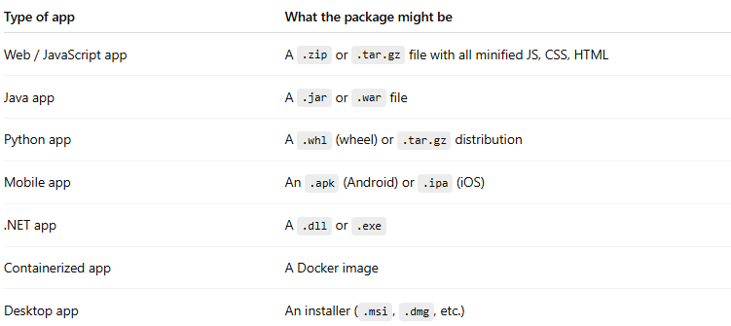
Type of app | What the package might be
Web / JavaScript app | A .zip or .tar.gz file with all minified JS, CSS, HTML
Java app | A .jar or .war file
Python app | A .whl (wheel) or .tar.gz distribution
Mobile app | An .apk (Android) or .ipa (iOS)
.NET app | A .dll or .exe
Containerized app | A Docker image
Desktop app | An installer (.msi, .dmg, etc.)

Why do we package?
- Consistency → same thing goes to every environment (test, staging, production)
- Portability → you can move the package between machines/servers
- Versioning → you can store each build (e.g., myapp_v1.2.3.zip)
- Speed → deployment is just dropping the package in place, no rebuilding needed

💡 In a CI/CD pipeline, this usually happens after:
- Automatic build → compile and assemble the app
- Automatic tests → verify it works
- Package → create the deployable artifact
- Deploy → move that artifact into a test or production environment

Delivery
# Source: Chatgpt (GPT-5-Standard) at [9/8/2025]
In software / DevOps terms, Delivery usually means:
Getting changes safely from development into a state where they are ready to be deployed and used — the entire process of building, testing, packaging, and preparing software for release.

🖼️ Quick breakdown
Term | Focus | Where it ends
Integration | Merging code changes frequently and testing them together | Verified build exists
Delivery | Making sure the verified build can be packaged, tested, and is ready for deployment at any time | The build is deployable
Deployment | Actually putting that build into a specific environment (test, staging, production) | Software is running there
Release | Making the deployed software available to end users | Users can interact with it

🚀 Related terms
- Continuous Delivery (CD) → Automating everything up to the point where a version can be deployed at any time (but a human might trigger it).
- Continuous Deployment → Takes it one step further — deployments happen automatically after passing all tests.

💡 In short:
Delivery = The whole process of taking code from developers and preparing it so it’s deployable (safe, tested, packaged).
Would you like me to give you a super simple analogy (e.g., like pizza delivery 🍕) for CI, delivery, deployment, and release?

Deployment
# Source: Chatgpt (GPT-5-Standard) at [9/8/2025]
In software terms, Deployment means:
Making a specific version of your software available in a particular environment (like test, staging, or production) so it can run and be used.

🔹 Simple explanation
- You build your code → you get an artifact (like a .jar, .exe, container image, web app package, etc.).
- You deploy it → copy/install/configure it on servers, cloud instances, mobile stores, etc., where it can actually run.

🔹 Common types of deployment
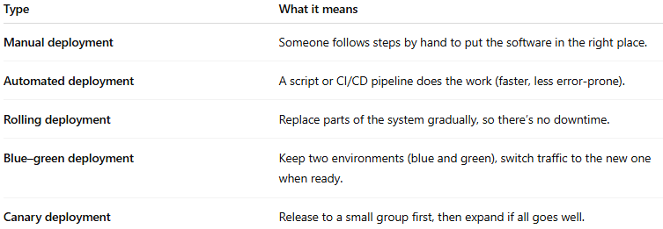
Type | What it means
Manual deployment | Someone follows steps by hand to put the software in the right place.
Automated deployment | A script or CI/CD pipeline does the work (faster, less error-prone).
Rolling deployment | Replace parts of the system gradually, so there’s no downtime.
Blue–green deployment | Keep two environments (blue and green), switch traffic to the new one when ready.
Canary deployment | Release to a small group first, then expand if all goes well.

💡 In short:
Deployment = taking a version of your application and moving it into an environment (often production) so that users or testers can actually use it.
Would you like me to also briefly explain the difference between deployment and release (they’re related but not the same)?

Environment types
# Source: Chatgpt (GPT-5-Standard) at [9/8/2025]
Here you go 👍 — a list of the most common environment types you’ll see in software development and testing pipelines, with a quick note on what each is for:
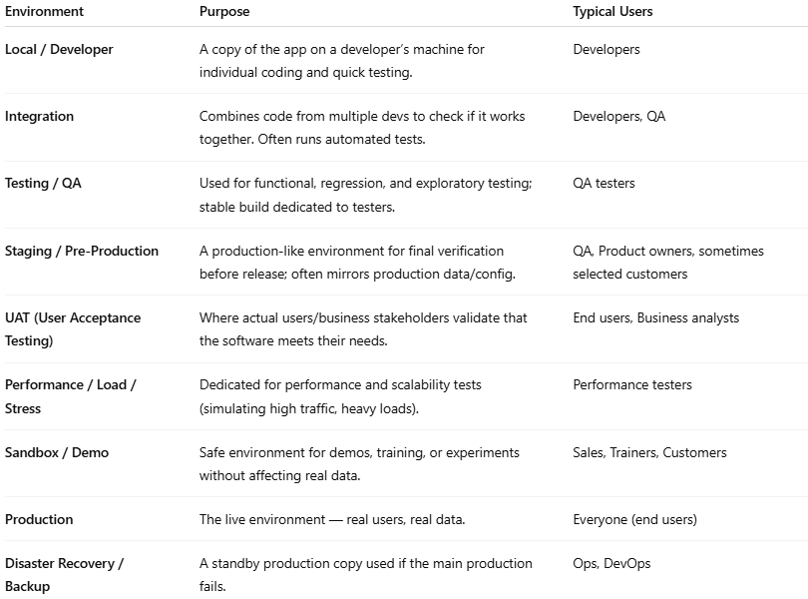
Environment | Purpose | Typical Users
Local / Developer | A copy of the app on a developer’s machine for individual coding and quick testing. | Developers
Integration | Combines code from multiple devs to check if it works together. Often runs automated tests. | Developers, QA
Testing / QA | Used for functional, regression, and exploratory testing; stable build dedicated to testers. | QA testers
Staging / Pre-Production | A production-like environment for final verification before release; often mirrors production data/config. | QA, Product owners, sometimes selected customers
UAT (User Acceptance Testing) | Where actual users/business stakeholders validate that the software meets their needs. | End users, Business analysts
Performance / Load / Stress | Dedicated for performance and scalability tests (simulating high traffic, heavy loads). | Performance testers
Sandbox / Demo | Safe environment for demos, training, or experiments without affecting real data. | Sales, Trainers, Customers
Production | The live environment — real users, real data. | Everyone (end users)
Disaster Recovery / Backup | A standby production copy used if the main production fails. | Ops, DevOps

Release
# Source: Chatgpt (GPT-5-Standard) at [9/8/2025]
In software terms, a Release is:
The act of making a specific version of your software available to its intended users.

🔹 Key points
- A release is about availability, not just technical deployment.
- You can deploy code to servers, but if users can’t access or use the new features yet, it’s not released.
- In modern DevOps, deployment and release are often decoupled — you might deploy features behind a “feature flag” and release them later.

🔹 How it fits with the other terms
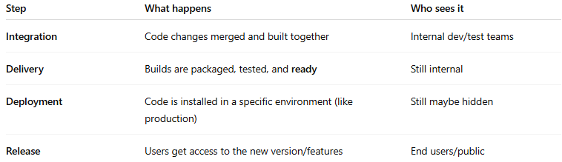
Step | What happens | Who sees it
Integration | Code changes merged and built together | Internal dev/test teams
Delivery | Builds are packaged, tested, and ready | Still internal
Deployment | Code is installed in a specific environment (like production) | Still maybe hidden
Release | Users get access to the new version/features | End users/public

💡 In short:
Release = when a particular software version or feature is officially launched for use by its target audience.
Would you like me to create a one-line analogy (like pizza 🍕) for each — Integration, Delivery, Deployment, and Release — to make them easier to memorize?

3-Software Delivery Pipeline
# Source: Chatgpt (GPT-5-Standard) at [8/13/2025]
A software delivery pipeline is the end-to-end automated process that takes code from development all the way to production, ensuring it’s built, tested, and deployed in a consistent and reliable way.

It’s essentially the full path your software follows — from a developer’s commit to a running, usable product for end users.
If a CI/CD pipeline is like an assembly line for each change, the software delivery pipeline is the entire manufacturing plant, covering all stages from code to customer.

Key Characteristics
# Source: Chatgpt (GPT-5-Standard) at [8/13/2025]
- End-to-end: Starts with source code changes and ends with deployed software.
- Automated: Minimal manual steps to reduce errors and speed up releases.
- Integrated with CI/CD: Continuous Integration (CI) + Continuous Delivery/Deployment (CD) stages.
- Repeatable & Reliable: Produces consistent results every time.

Typical Stages in a Software Delivery Pipeline
# Source: Chatgpt (GPT-5-Standard) at [8/13/2025]
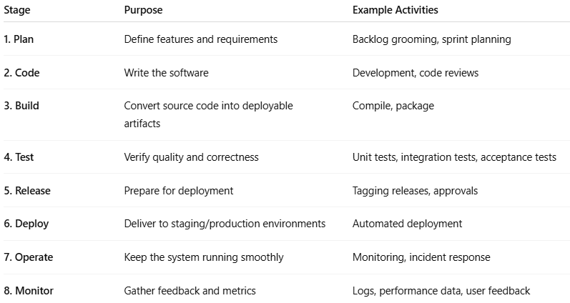
Stage | Purpose | Example Activities
1. Plan | Define features and requirements | Backlog grooming, sprint planning
2. Code | Write the software | Development, code reviews
3. Build | Convert source code into deployable artifacts | Compile, package
4. Test | Verify quality and correctness | Unit tests, integration tests, acceptance tests
5. Release | Prepare for deployment | Tagging releases, approvals
6. Deploy | Deliver to staging/production environments | Automated deployment
7. Operate | Keep the system running smoothly | Monitoring, incident response
8. Monitor | Gather feedback and metrics | Logs, performance data, user feedback

Example Flow
# Source: Chatgpt (GPT-5-Standard) at [8/13/2025]
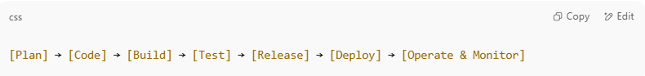
[Plan] → [Code] → [Build] → [Test] → [Release] → [Deploy] → [Operate & Monitor]

In modern DevOps:
- Each commit triggers automated builds and tests.
- If all checks pass, the code is automatically deployed to staging or production.
- Continuous monitoring feeds back into the next planning cycle.

Why It’s Important
# Source: Chatgpt (GPT-5-Standard) at [8/13/2025]
- Faster delivery: Shortens time from idea to user.
- Higher quality: Testing is built in, catching issues early.
- Better collaboration: Developers, testers, and operations work as one team.
- Lower risk: Small, frequent releases are less risky than big-bang deployments.

